Q. 1 Implement Bellman Ford Algorithm on following graphs
Graph – 1
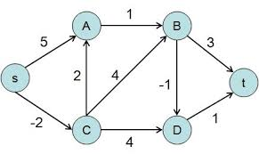
Graph-2
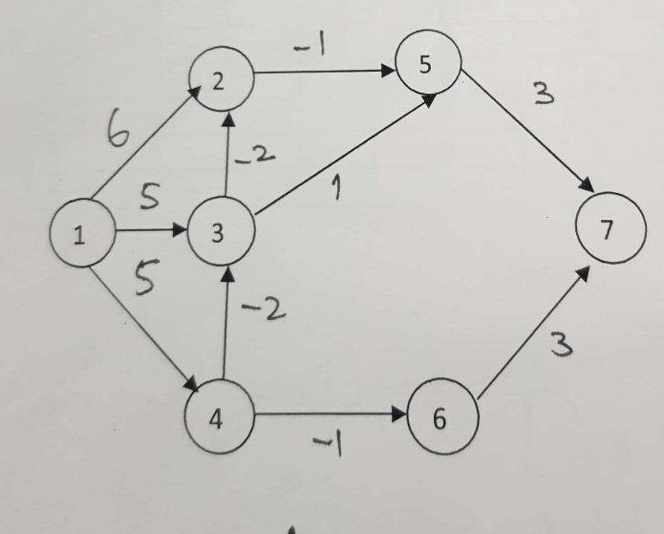
Q.2. Implement All pair Shortest Path Algorithm on following graphs
Graph – 1
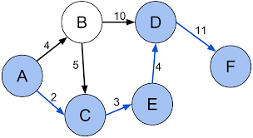
Graph – 2
