Department of Computer Science and Engineering
Course: Design and Analysis of Algorithms
Shift-I
Assignment-Set-6
Max.Marks: 10
Last date of submission: 19-Oct-2019
(Students can also submit assignment in any other programming language)

Q.1] Write python program for sum of subset problem. Generate three different test cases.
Roll no 51

Q.2] Consider String built in function like, strcmp, strlen. Write python program to demonstrate reduction principle of problem solving in string domain
Roll no 53

Q.3] Write program to demonstrate the application of Breadth first Search and Depth first Search in python language.
Roll no 54

Q.5] Implement python program for graph colouring. Use following graph to demonstrate test case
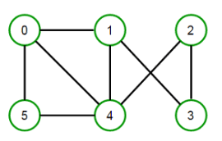
Roll no 55

Q.6] Write python program for string editing. Demonstrate the use of program for spell checking application
Roll no 56

Q.7] Q.1] Read the distance data from Google Map related to 10 Cities. Create a distance matrix/data frame.
Write a program in python to implement Kruskal Algorithm Roll no 57

Q.8] A data of marks of 1000 students appeared in JEE exams is to be generated using random number generator in python. The data values must be in between 10-90.

Write a program in python [recursive and iterative] to find Maximum and Minimum value from the list [use min_max algorithm] How to use inbuilt stack in python. [Roll no 58]

Q.9] A data of marks of 1000 students appeared in JEE exams is to be generated using random number generator in python. The data values must be in between 10-90. Sort the data using any sorting algorithm.
Write a program in python the search an element. Also draw the search tree. [Roll no 60]

